**PROJECT SCREENSHOTS**

**Both Front-end And Back-end Files are Uploaded in GitLab**

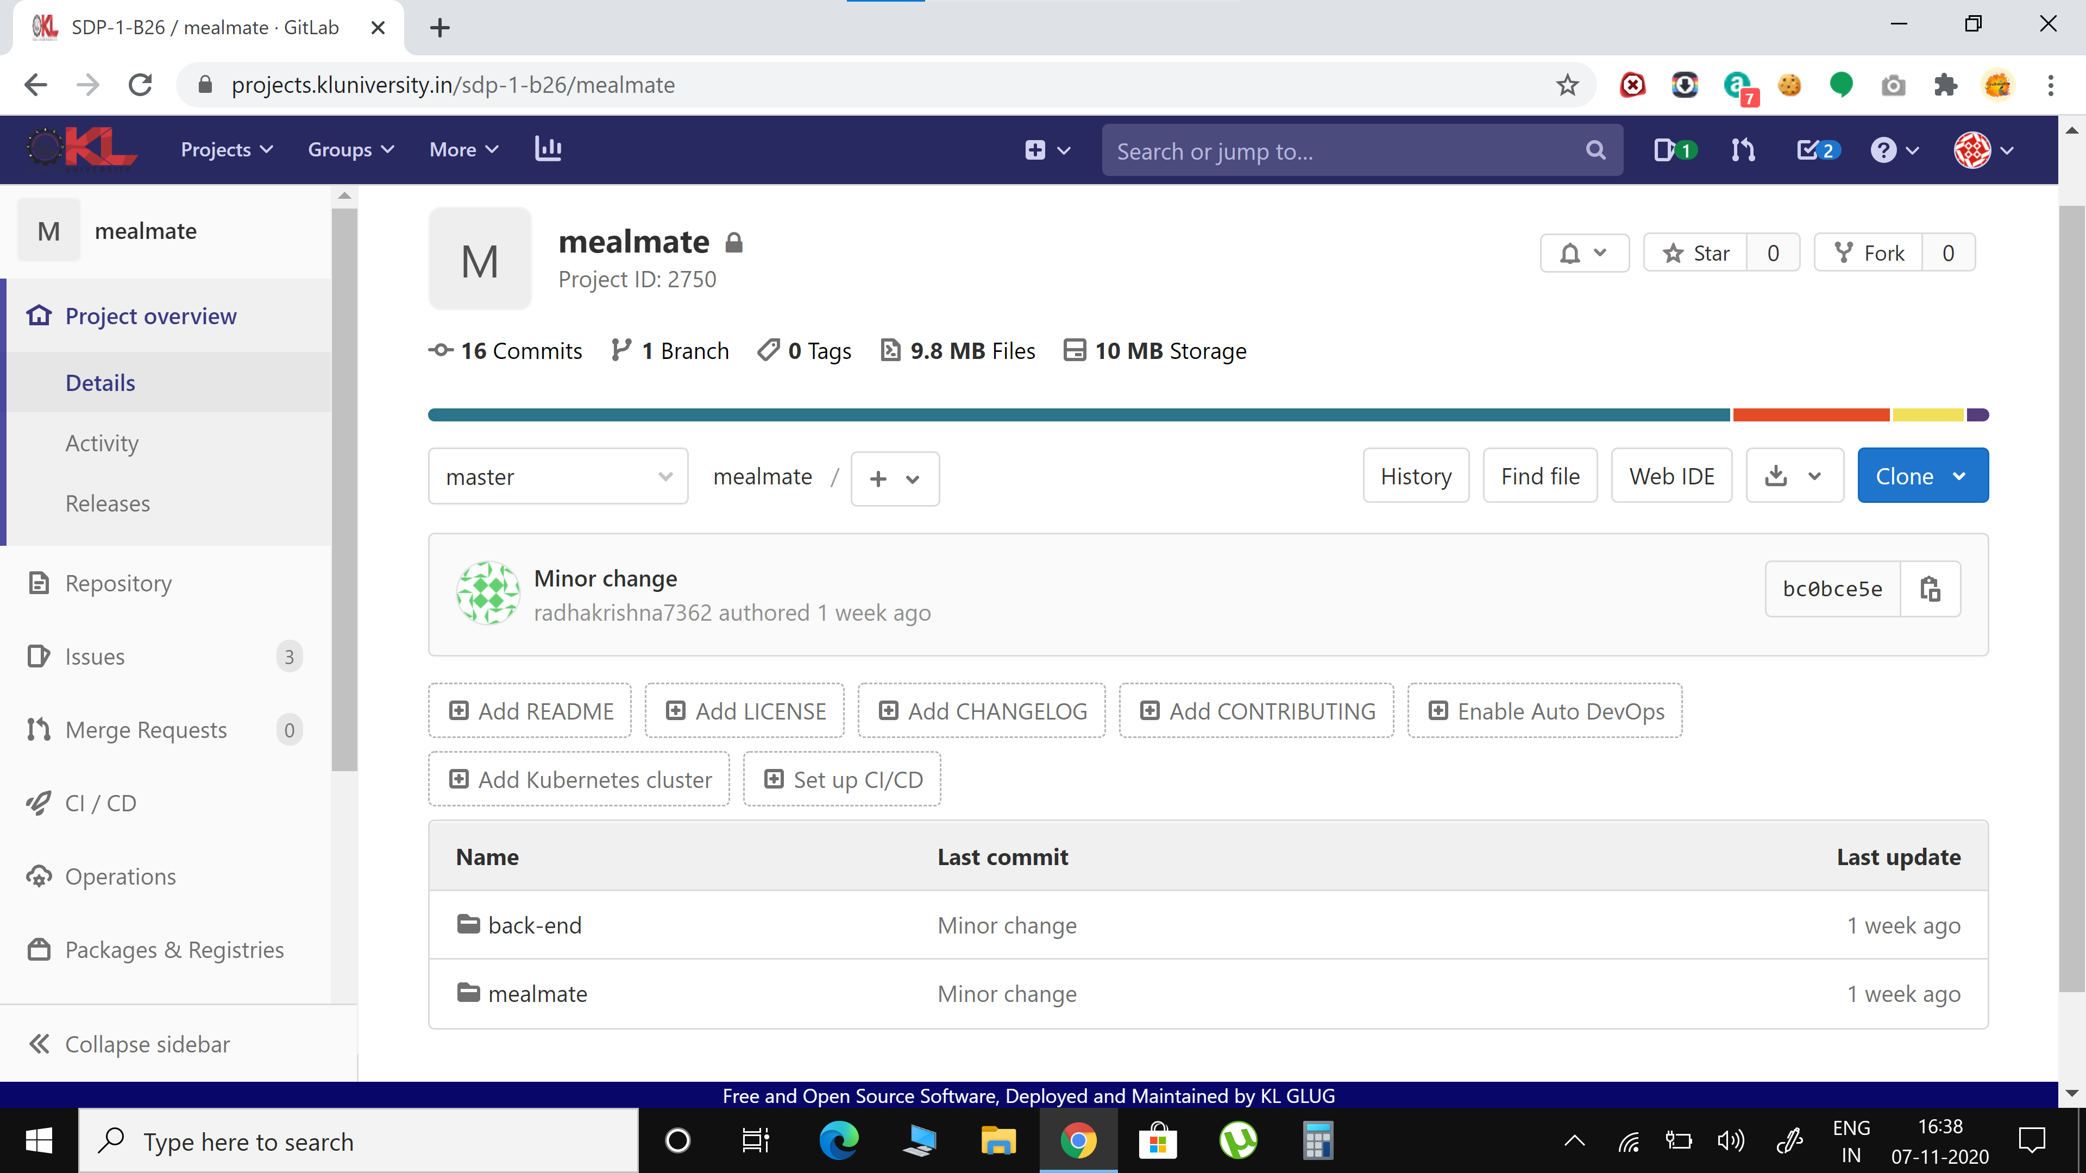

**Back-end Files Uploaded in GitLab**

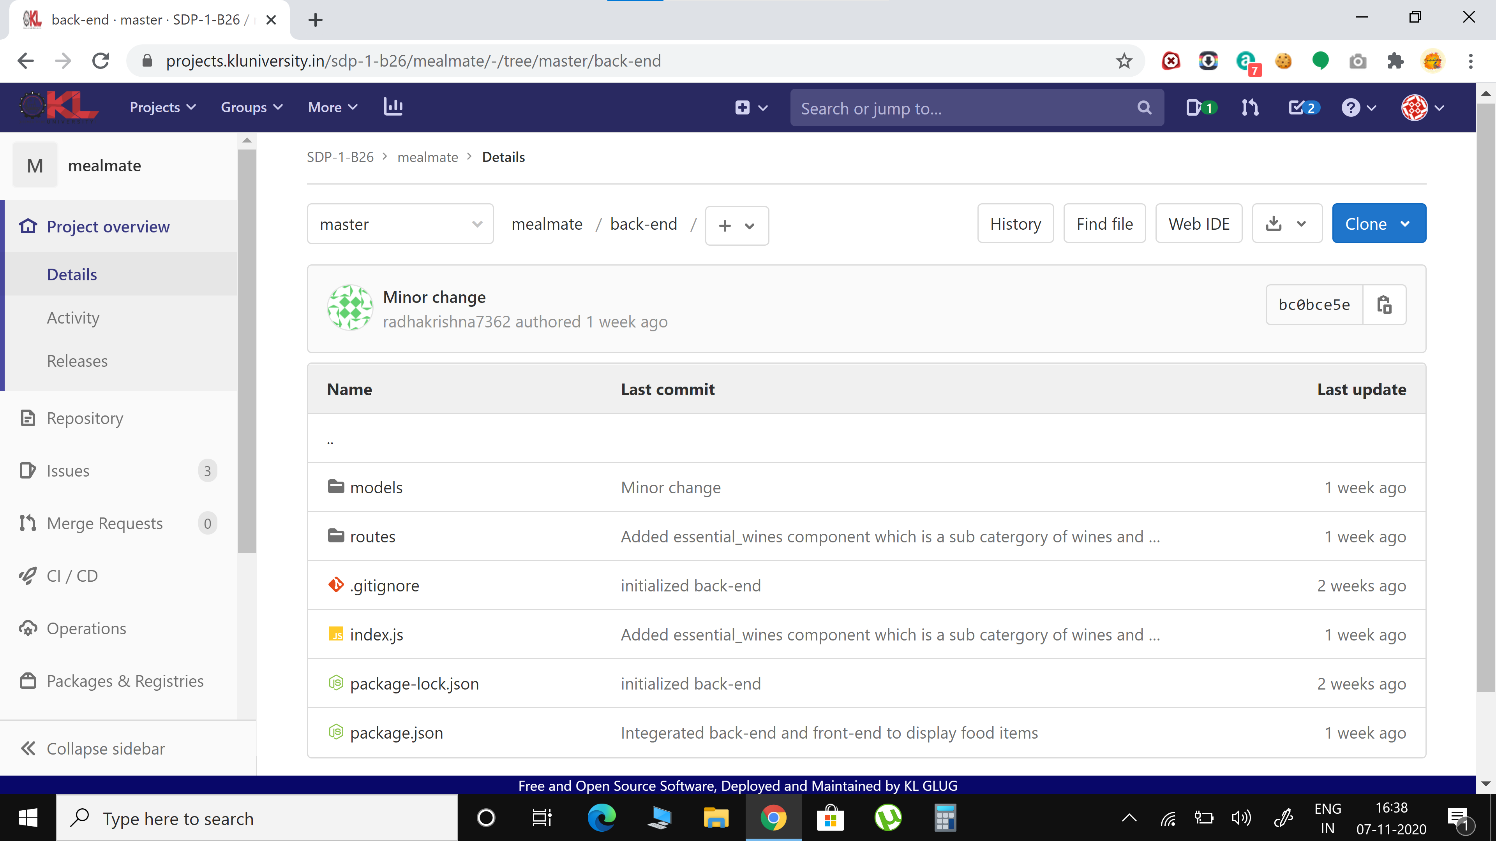

**Schema and Data of Collections needed for the project Uploaded in GitLab**

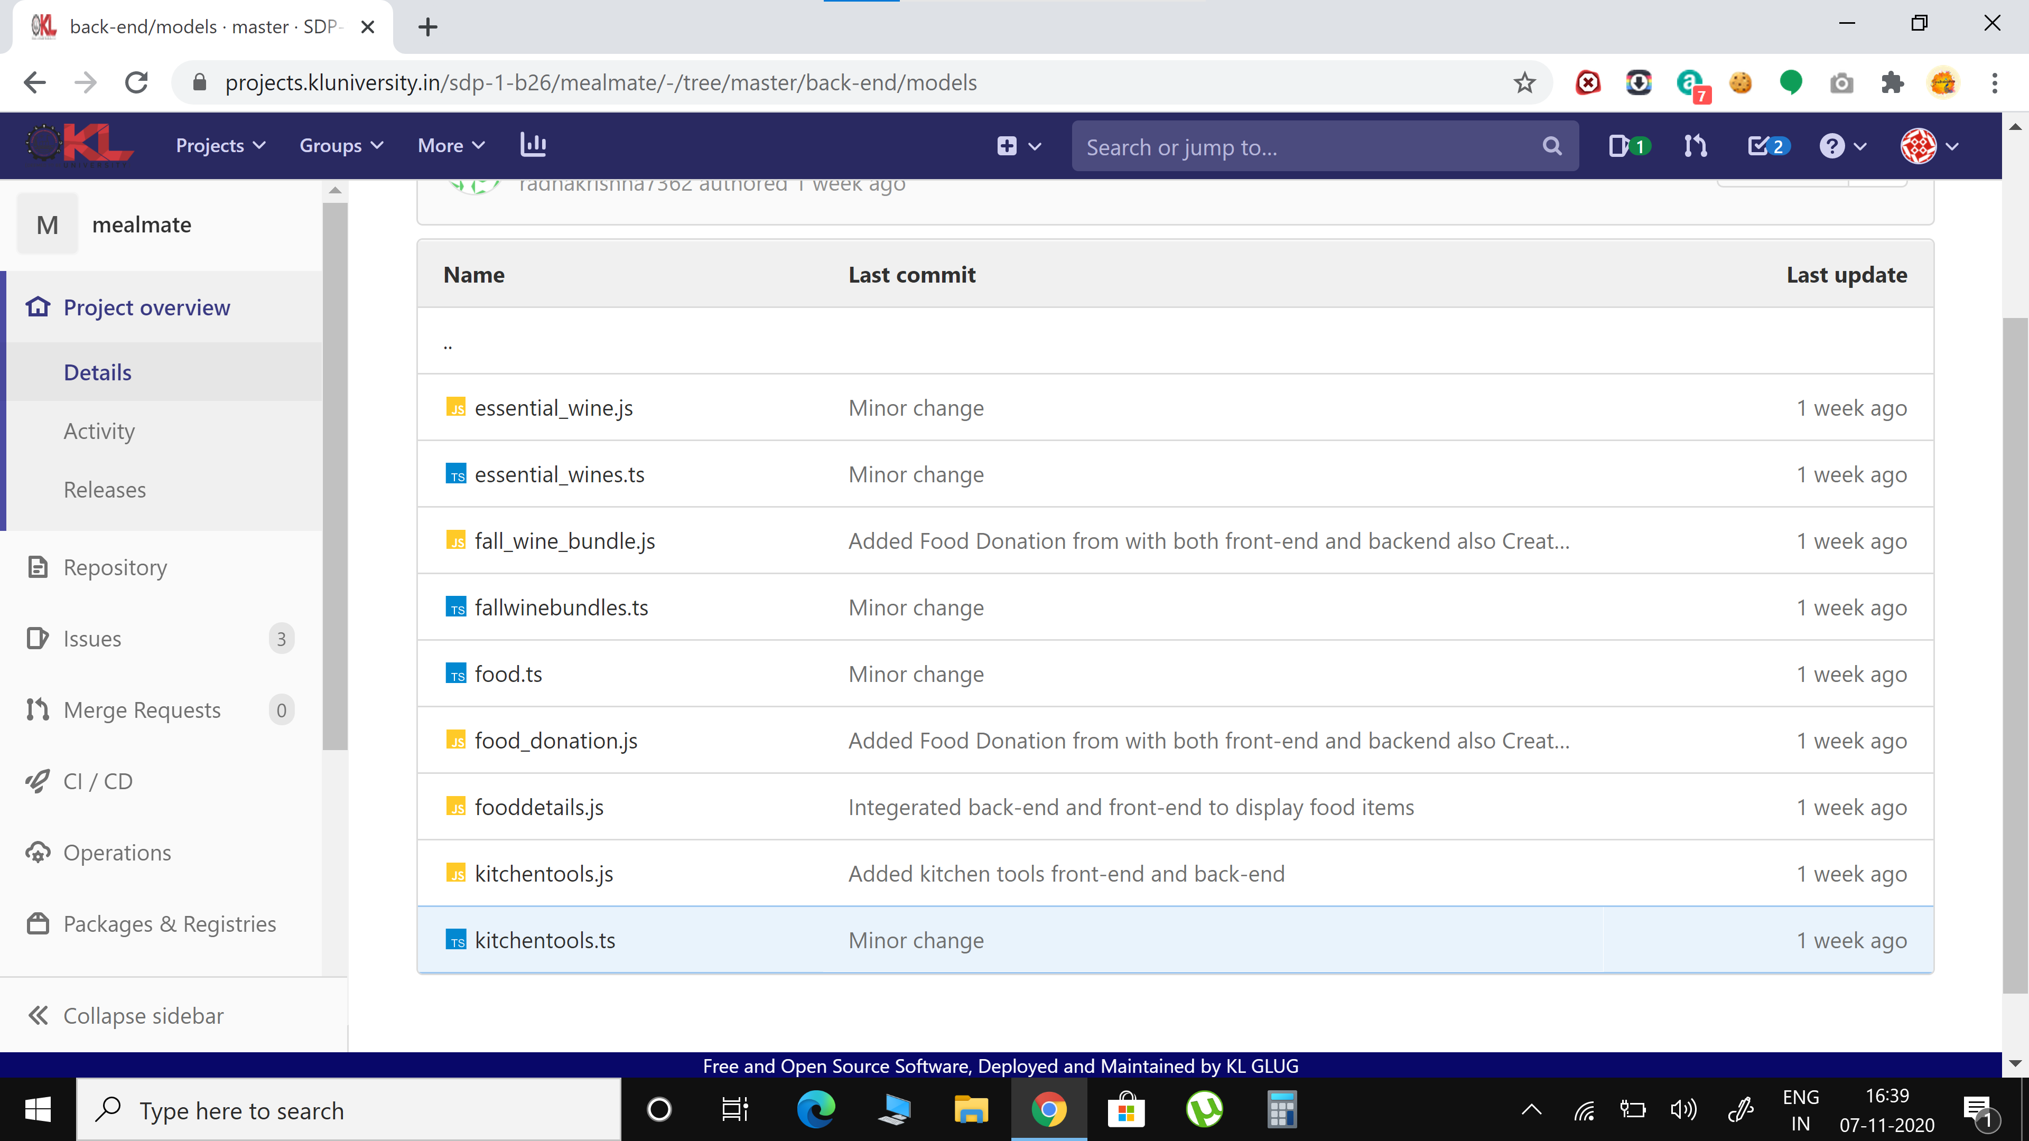

**MongoDB Database Used for the project**

**Name of the Database is mealmate**

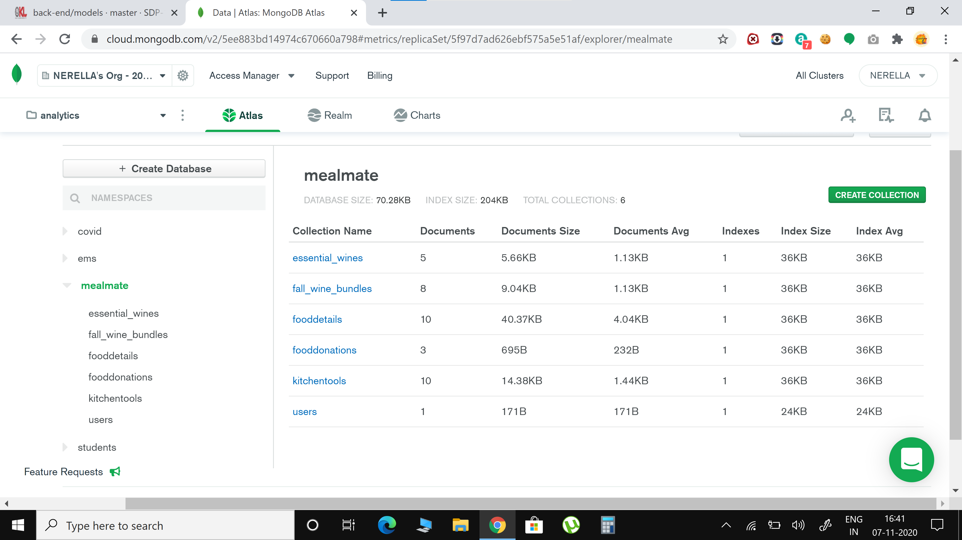

**Screenshots of Data stored in Collections**

